FOR TARGET : Tesla .com

Some Public Documents that I found🡪

Dork used 🡪 site: tesla.com filetype:pdf OR filetype: DOCX

TFF_Broschüre_Alles_rund_um_ihren_Tesla_V1 (1).pdf

tsla-20221231-gen.pdf ---> pdf file

[Power of Attorney Tesla.docx-----> DOCX file](https://www.tesla.com/sites/default/files/downloads/en_EU/Power%20of%20Attorney%20Tesla.docx)

[Master Plan Part 3 --> pdf file](https://www.tesla.com/sites/default/files/downloads/en_EU/Power%20of%20Attorney%20Tesla.docx)

Some Login Pages & Admin Panels that I found using dorks🡪

Dork used 🡪 🡪 site: tesla.com inurl : login

[https://www.tesla.com/user/login --> Login Page   
https://service.teslamotors.com ---> tesla service login page](https://www.tesla.com/user/login    --> Login Page https://service.teslamotors.com ---> tesla service login page )

I cant find anything for admin in url but some titles contain admin that I am mentioning here ->

[Admin & HR Business Partner](https://www.tesla.com/careers/search/job/admin-hr-business-partner-226186)

Some public backup / config files that I found 🡪

I don’t think there are any config or backup files all I found is some pdfs or reports in which models configurations words are used

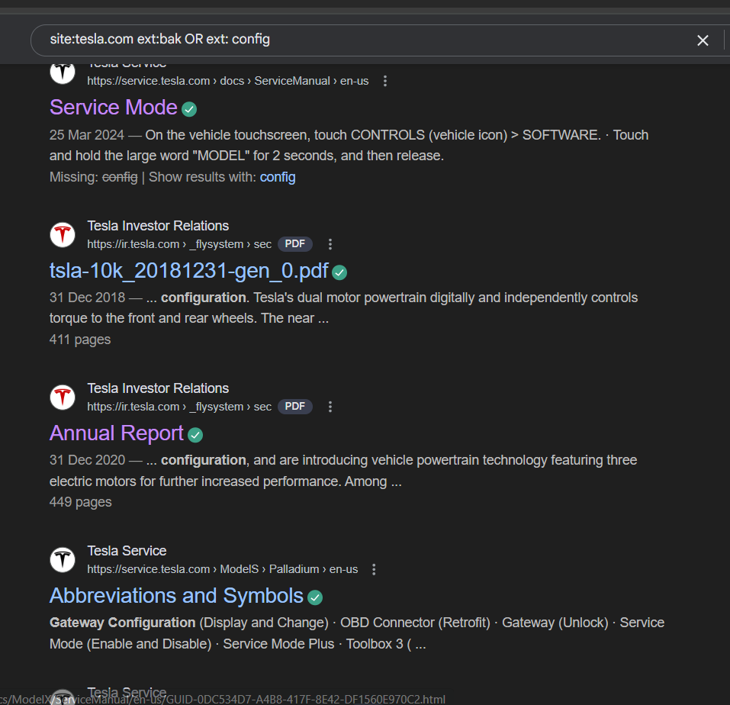

No .log files sre found for target tesla.com but found some files with title as undefined error 🡪

[undefined Error](https://www.tesla.com/he_IL/findus?bounds=50.034535973301956%2C-67.69189571875%2C28.263710960523248%2C-130.84130978125&location=Daejeon)

also found this login page error 🡪

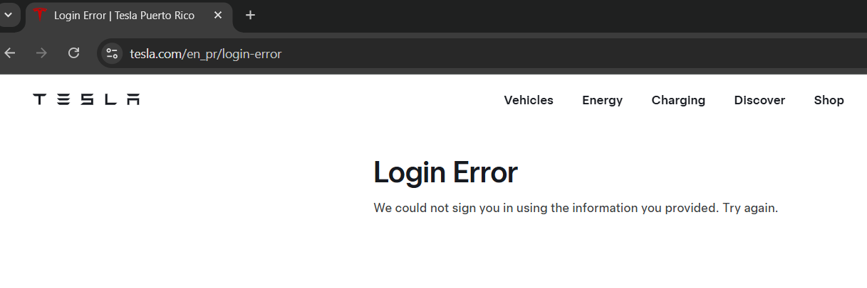

Dork used 🡪

site:tesla.com inurl:error

site:tesla.com inurl:log

site:tesla.com ext:log

site:tesla.com ext:error

found this investor relation press release which contain lots of emails and stuff of press🡪

[Tesla Investor Relations](https://ir.tesla.com/)

found this file or pdf while searching for env or git files

[Fleet API documentation](https://developer.tesla.com/docs/fleet-api)

But found no git inventories that are publicly available or env files

TARGET : ibm.com

Some public docs that I found:

Found this xlsx file->

[Exporting Payee Ledger to Excel](https://www.ibm.com/docs/en/SSGKS6_8.1.1/com.ibm.swg.ba.cognos.ug_adm.8.1.1.doc/t_toolsadmin_export_payee_ledger_to_excel_.xlsx_or_.xls.html)

Dork used : site:ibm.com filetype:pdf OR filetype : xlsx

[Model input and output data file formats for Decision ..](https://www.ibm.com/docs/en/watsonx/saas?topic=programmatically-model-input-output-data-file-formats)

[PDF file for Performance](https://www.ibm.com/docs/en/i/7.5?topic=performance-pdf-file)

[---> pdf file publicly available](https://www.ibm.com/docs/en/watsonx/saas?topic=programmatically-model-input-output-data-file-formats)

Some login and admin panels 🡪

Using dorks-:

Site:ibm.com inurl:admin OR inurl:login

[login - ClearCase](https://www.ibm.com/docs/en/clearcase/11.0.0?topic=ucm-login)

[REGISTER ADMIN (Register an administrator ID)](https://www.ibm.com/docs/en/storage-protect/8.1.24?topic=commands-register-admin-register-administrator-id)

Commands to add admin to a server

Some public backup and config files

Found many config files but not public backup files :

[install.config file reference](https://www.ibm.com/docs/SSWRJV_10.1.0/lsf_config_ref/install.config.5.html)

only found this🡪

Changing trace settings from the IBM Integration Explorer

Using dork 🡪 site:ibm.com ext : bak

Site:ibm.com ext:config OR inurl: config

Found many log titled files 🡪

[Log source extension management](https://www.ibm.com/docs/en/dsm?topic=management-manage-log-source-extensions)

dork used

site:ibm.com ext:.log inurl:log / ext:error// inurl:error

[Log and Trace extensions](https://www.ibm.com/docs/SSEQTP_9.0.5/com.ibm.websphere.base.doc/ae/rtrb_logtraceextensions.html)

cant find any error pop ups

found many files using dork

site:ibm.com "@ibm.com"

but none contain any vulnerables just normal available data from ibm

example..->

[Contact IBM](https://www.ibm.com/contact/global)

Found some git repositoried publicly available by ibm🡪

[Git repository projects .ibm](https://www.ibm.com/docs/vi/SSHGWL_1.2.3/local/git.html)

Some env files as well🡪

[-env.ibm](https://www.ibm.com/docs/en/SSWRJV_10.1.0/lsf_command_ref/bsub.env.1.html)

target -> google.com

some pdf and docx files using dork ->

[د.docx - Google Groups](https://groups.google.com/group/groupnasr/attach/5e714919033f0/%D8%AF.docx?part=0.1)

[CSE-TR-292-96.pdf - CMU School of Computer Science](https://sites.google.com/site/xiuzhong/res_sat1.pdf)

using dork 🡪 site:google.com filetype:pdf OR filetype: DOCX

,

Some login pages on google.com

[gcloud auth login | Google Cloud CLI Documentation](https://cloud.google.com/sdk/gcloud/reference/auth/login)

for admin🡪

[Admin console | Google for Developers](https://developers.google.com/workspace/admin)

Some config files🡪

[news.config](https://groups.google.com/g/news.config)

[Package com.google.appengine.api.log (2.0.0)](https://cloud.google.com/appengine/docs/standard/java-gen2/reference/services/bundled/latest/com.google.appengine.api.log)

🡪using dorks site:google.com ext:log

site:google.com ext:bak

some error files and .env

[Greenlight ERROR: Couldn't find env file](https://groups.google.com/g/bigbluebutton-dev/c/g6PMzlQV2XI)

Git repo found by dork

site:google.com inurl:.git

[git(hub)_tutorial.ipynb](https://colab.research.google.com/github/schwallergroup/ai4chem_course/blob/main/notebooks/11%20-%20Model%20deployment/git(hub)_tutorial.ipynb)

[Welcome to My Activity](https://colab.research.google.com/github/schwallergroup/ai4chem_course/blob/main/notebooks/11%20-%20Model%20deployment/git(hub)_tutorial.ipynb)

url i found while finding some contacts cant find any ending with @ googlee .com

_--------------------------------------------------------------------------------------------------------------------_